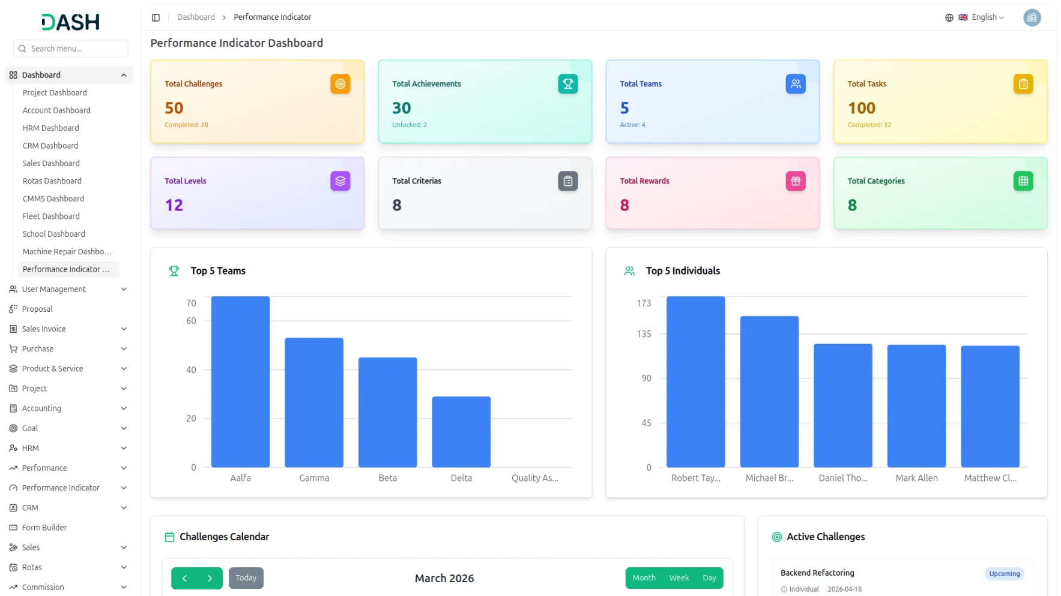

The Performance Indicator Add-On transforms daily work into structured, goal-driven challenges and achievements, linking effort directly to measurable outcomes through XP and rewards. It provides transparent tracking for both individual and team performance, fostering motivation, accountability, and continuous progress. With integrated leaderboards, analytics, and flexible configuration, organizations can easily monitor, manage, and reward performance across all levels.

Gamified XP & Leaderboard Management System
Represents a comprehensive dashboard system designed to gamify progress tracking within teams or individuals through challenges and experience points (XP). The central Add-On connects to key functionalities such as challenge creation, leaderboard management, team and individual project types, and detailed member progress tracking. Core menu options include access to achievements, team structure, system setup, and more. A specialized settings panel allows XP conversion customization, enabling leaders to allocate XP based on contributions. The system supports both team and individual performance tracking through dedicated leaderboards, promoting engagement, transparency, and motivation.
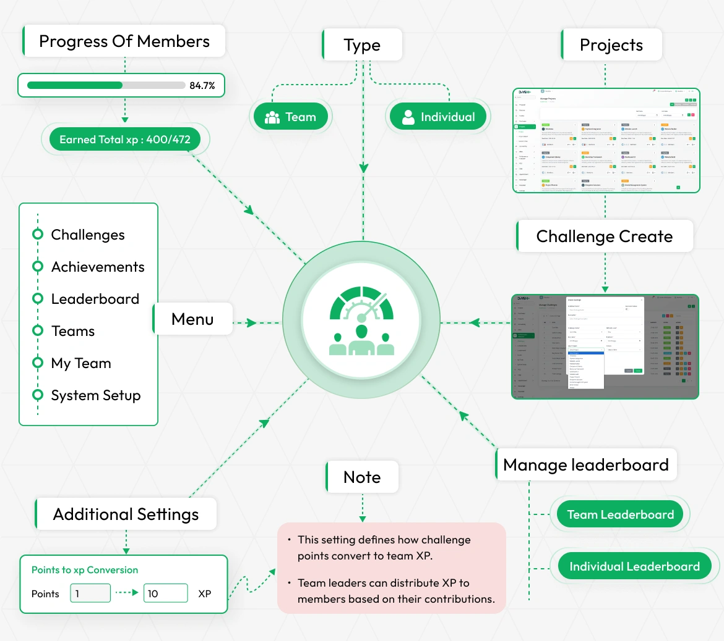
STRONG BRAND
Challenge & Achievement Management
The Performance Indicator Add-On helps organizations turn daily work into structured, goal-driven challenges for teams and individuals. Each challenge is clearly defined with difficulty levels, criteria, and rewards, making expectations transparent. Completed challenges are scored and converted into XP, linking effort directly to measurable outcomes. Alongside this, milestone-based achievements reward progress, creating a continuous cycle of motivation and engagement.
- Challenges can target teams or individuals with rewards
- Difficulty levels and criteria ensure consistent scoring
- Achievements unlock automatically or through admin verification
- Challenges and achievements drive overall progress and levels

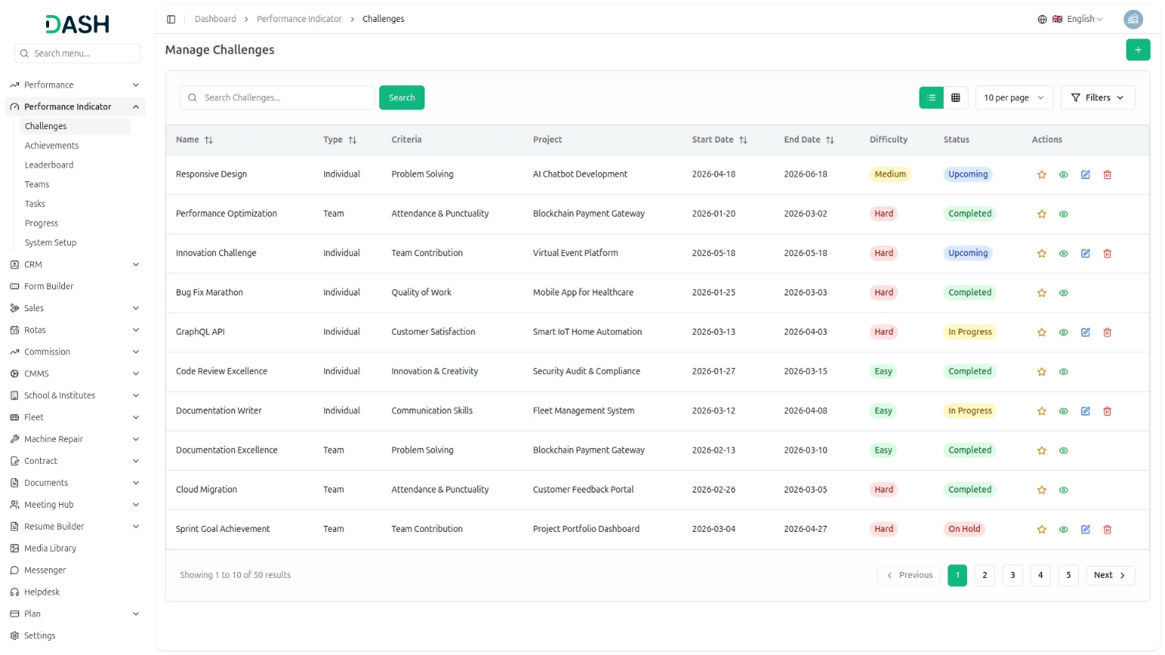
Team Organization & Task Management
This Add-On helps organizations manage team performance by breaking group goals into individual contributions. Teams earn a shared XP pool from completed challenges, which leaders distribute through assigned tasks. Each task is tied to specific roles and carries its own XP value for clear accountability. The system tracks XP usage, ensuring every member’s effort is recognized within the team outcome.
- Teams have leaders managing XP distribution among members
- Tasks link directly to challenges, ensuring traceable work
- XP budget system keeps allocation fair and transparent
- Task completion updates each member’s XP profile instantly
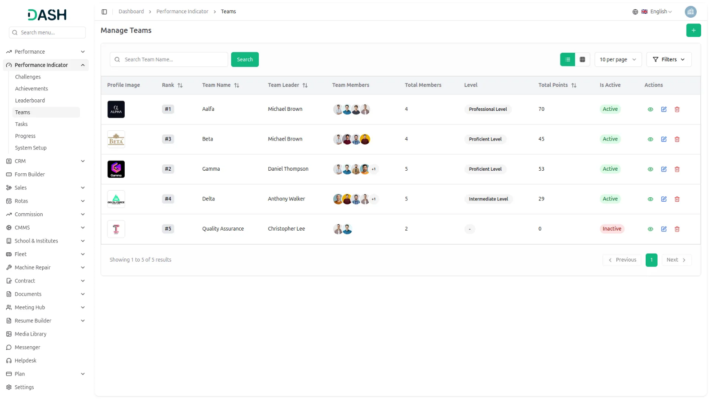

Leaderboard & Ranking System
The Global Leaderboard ranks both teams and individuals based on points and XP earned. Teams are evaluated on collective challenge points, while individuals are ranked by personal XP from tasks and challenges. This dual system ensures equal recognition for both team effort and individual contribution. It encourages healthy competition while giving management a clear, data-driven view of overall performance.
- Separate leaderboards highlight both team and individual contributions
- Team rankings use points, individuals are ranked by XP
- Leaderboards update continuously as tasks and challenges complete
- Top contributors shown with level, XP, and team

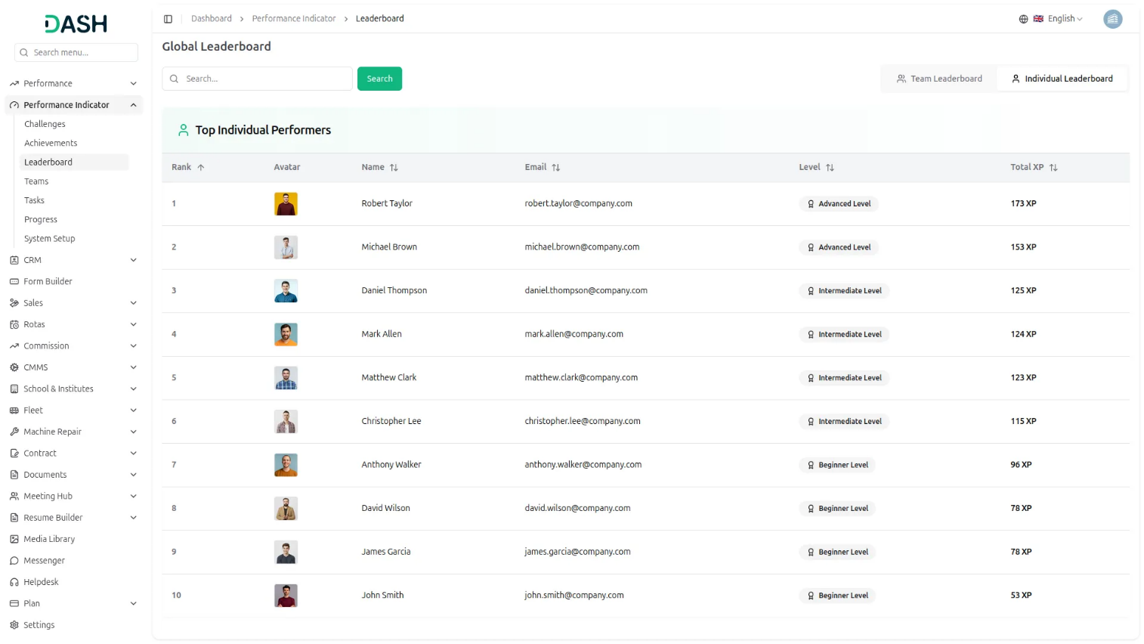
Personal Progress Tracking & Analytics
Each member gets a personal performance overview showing their XP, achievements, and current level. It clearly separates XP earned from team tasks and individual challenges for better transparency. The dashboard also highlights upcoming tasks, overdue work, and progress toward the next level. Admins can view any member’s overview, making performance tracking simple and centralized.
- XP tracked separately for tasks and challenges transparency
- Level progression shows targets and required XP clearly
- Overdue tasks and challenges highlighted for quick action
- Achievements, challenges, and tasks visible in one view
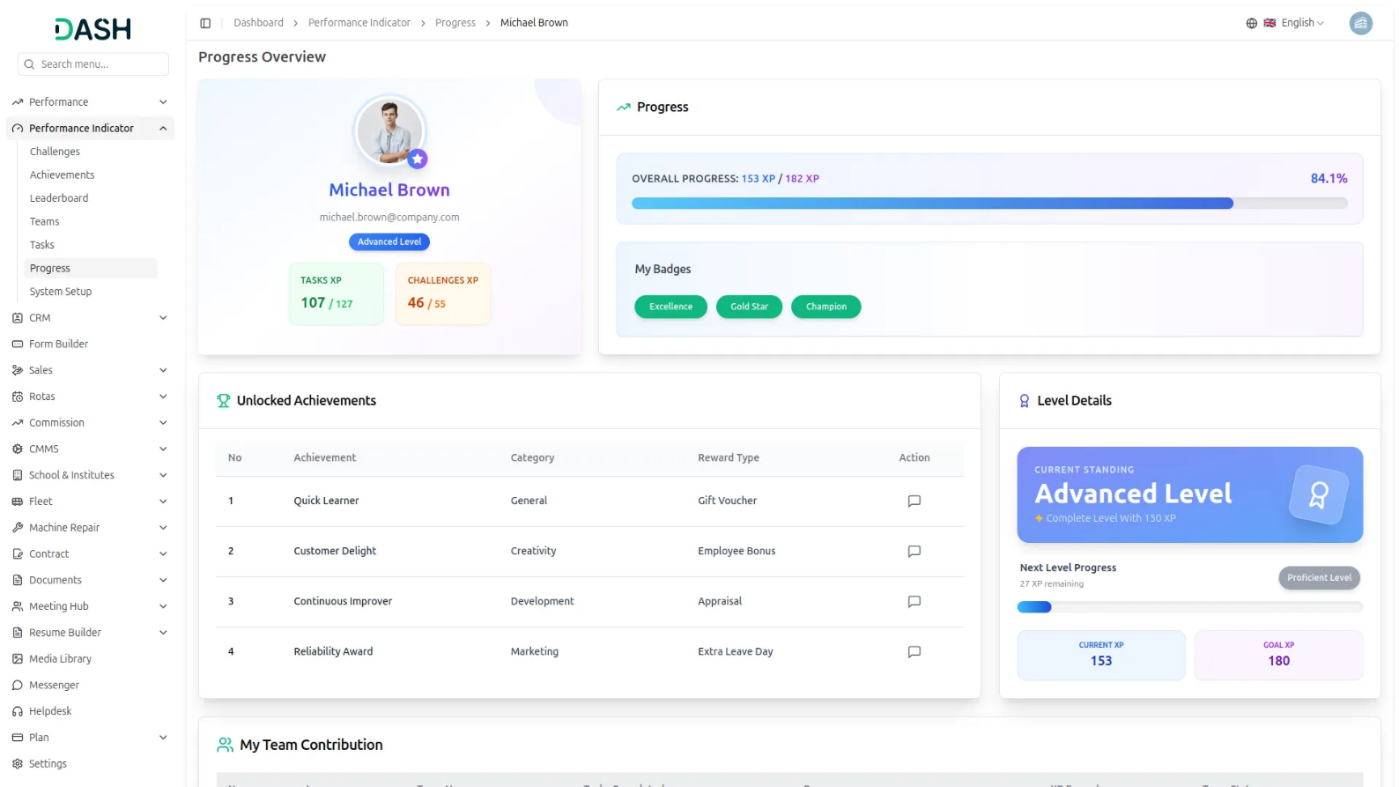
System Setup & Configuration
The Performance Indicator Add-On starts with a strong configuration setup to define how performance is measured and rewarded. Organizations can create difficulty levels, set criteria, and structure categories for challenges and achievements. It also allows defining reward types and setting a points-to-XP conversion rate for consistency. This setup ensures all performance data remains clear, fair, and predictable across the system.
- Difficulty levels, criteria, categories customized to organization needs
- Reward types flexible for individuals, teams, or both
- Points to XP conversion applied automatically to challenges
- Configuration changes apply without affecting existing scores data
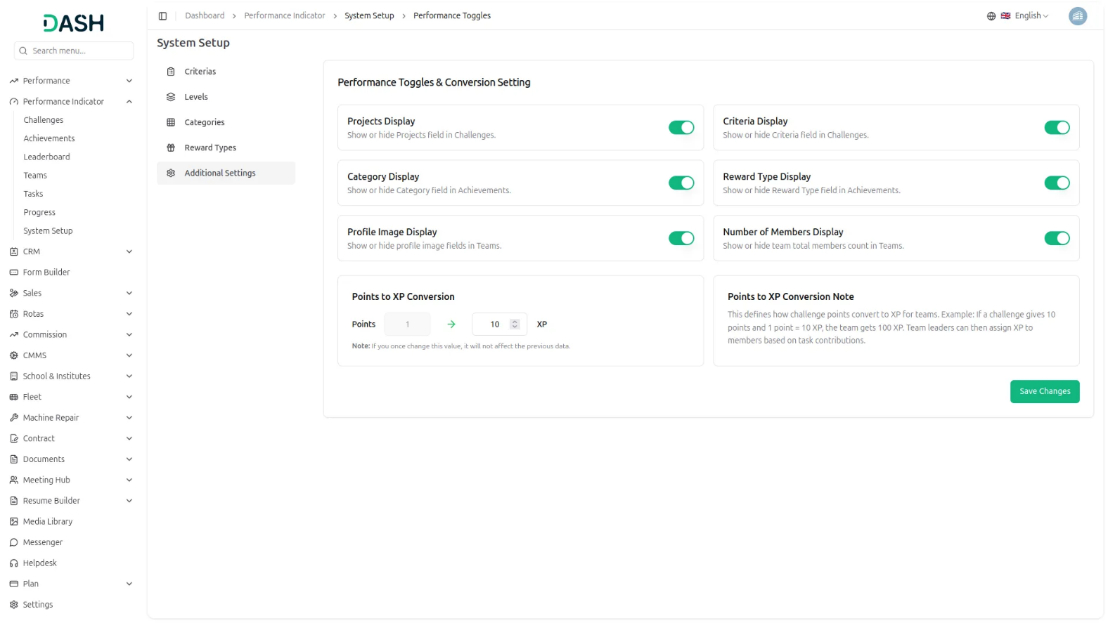

Introduction
The Performance Indicator Add-On is a gamification system designed to track and reward both team and individual performance within an organization. It works by assigning challenges to teams and individuals, converting earned points into XP, and distributing that XP to members through tasks. Admins configure the system, create and score challenges, and monitor performance through the dashboard and leaderboard. Team Leaders distribute XP to members based on task contributions, while members track their own progress, levels, and achievements through their personal Progress Overview page, creating a motivating environment that encourages both team collaboration and individual excellence.
How To Use the Performance Indicator Add-On?
Performance Indicator Dashboard
- The dashboard displays eight summary cards at the top, each showing a key metric such as total challenges, achievements, teams, tasks, levels, criteria, rewards, and categories, along with a sub-count like completed or active items.
- This bar chart ranks the five highest-scoring teams by their total points. It lets the admin quickly identify which teams are leading and which may need attention.
- This bar chart ranks the five highest-scoring members by their total XP. It gives the admin a clear picture of individual contributions and top performers across the entire organization.
- The calendar plots every active challenge on its scheduled date so the admin can see how challenges are distributed across the month. You can switch between Month, Week, and Day views and move between time periods using the navigation arrows.
- This panel lists all currently running and upcoming challenges along with the challenge type, scheduled date, and status, either In Progress or Upcoming. It helps the admin monitor which challenges are active at any given time.
- This panel displays the most recently active teams with their team code and current status. It gives the admin a quick reference for all teams currently operating within the system.
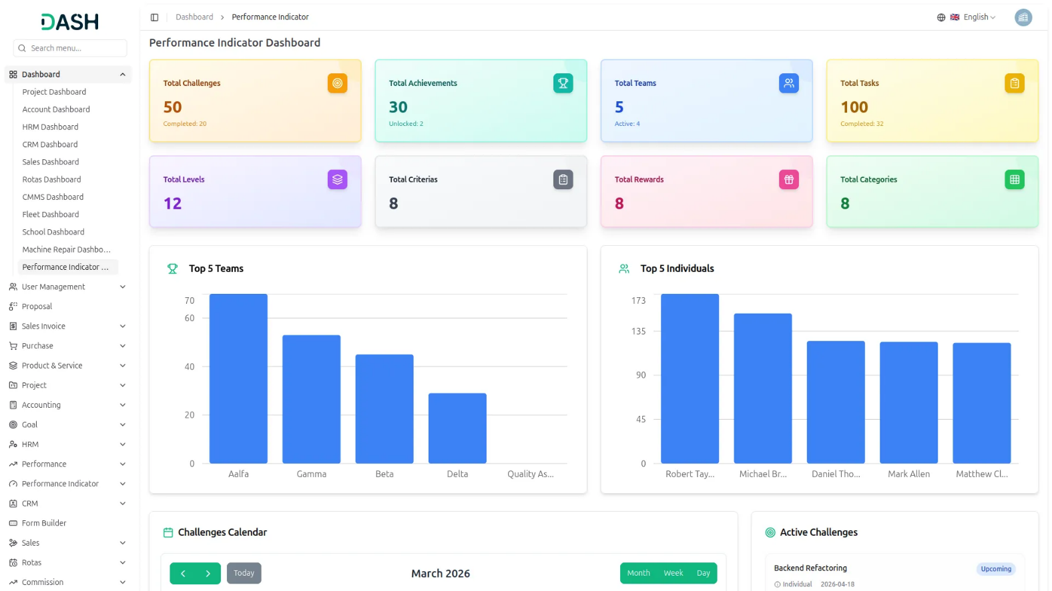

Role-based dashboard
- The Performance Indicator Dashboard adapts its content based on the user’s role. A Team Leader sees a more detailed view with team management controls, while a Staff member sees a simplified personal performance view.
Team Leader Dashboard
- The Team Leader dashboard shows eight summary cards covering Total Challenges, Total Achievements, Total Tasks, Active Teams, Total XP Earned, Contribution XP, Assigned Tasks, and Total Team Members. This gives the leader a broad view of both their personal performance and the teams they manage.
- The Performance Calendar shows tasks and challenges assigned to the team leader, which will be displayed month-wise with specific dates. Upon clicking a date, a pop-up will open showing the details of the corresponding challenges and tasks.
- The Active Tasks panel lists the leader’s own assigned tasks, showing which team the task is under, the XP they can earn, and the current progress status.
- The Active Challenges panel shows the challenges the leader is participating in, along with dates and statuses, allowing the leader to monitor progress across the board.
- The Managed Teams section at the bottom displays the teams directly under the leader’s supervision, shown as cards with the team name, code, and active status.
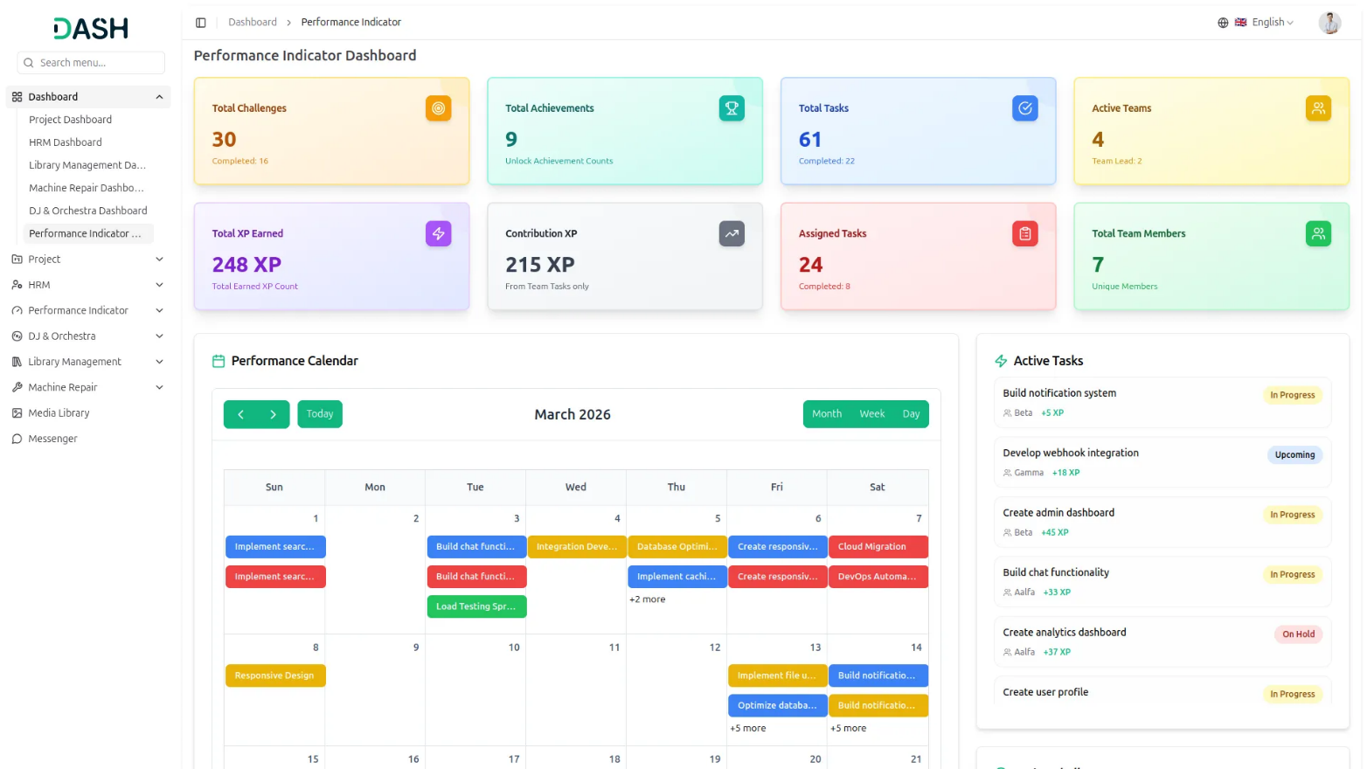

Employee Dashboard
- The Employee dashboard displays four summary cards: Total Challenges, Total Achievements, Active Teams, and Total XP Earned, providing each member with a focused view of their own performance and progress.
- The Performance Calendar shows only the tasks and challenges relevant to that member’s assigned teams, keeping the view clean and focused.
- The Active Tasks panel lists the member’s own assigned tasks, showing which team the task is under, the XP they can earn, and the current progress status.
- The Active Challenges panel shows the challenges the member is participating in, along with dates and statuses, so that they can stay on top of their own commitments.
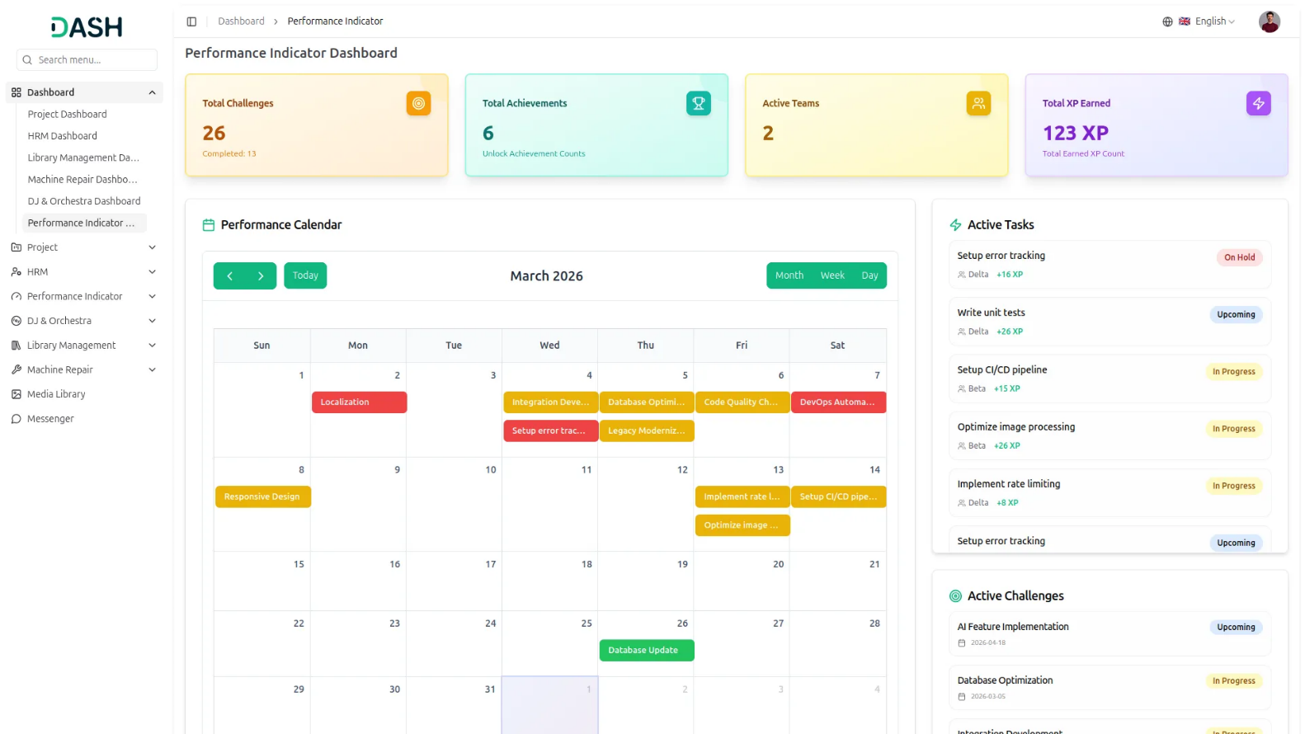
System Setup
- The System Setup section allows you to configure the essential building blocks of your performance tracking system. The settings you define here, such as Criterias, Levels, Categories, and Reward Types, are used throughout the platform and directly affect how Teams, Challenges, and Achievements behave.
Criterias
- To create a new Criteria, click the “Create” button, enter the Criteria Name, and set the Status as Active or Inactive.
- The list page displays all existing criteria along with their current status, with Edit and Delete options available for each entry.
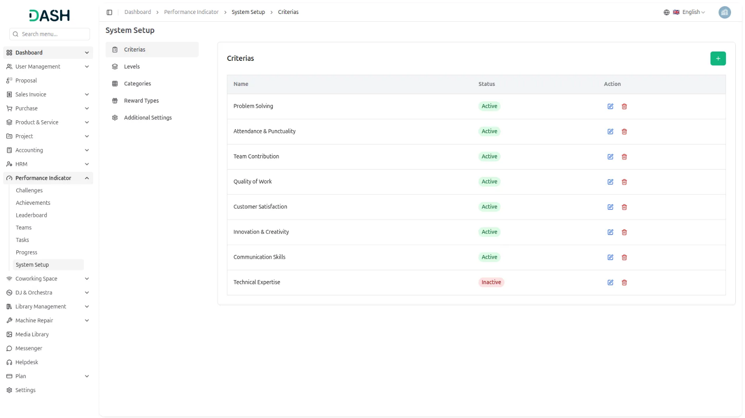
Levels
- To create a Level, click the “Create” button and fill in the Name, select the Difficulty Level from Easy, Medium, or Hard, enter the XP (Individual) and Points (Team) values, and add a Description.
- The list displays all configured levels showing their difficulty, XP, points, and description, with Edit and Delete options available for each entry.
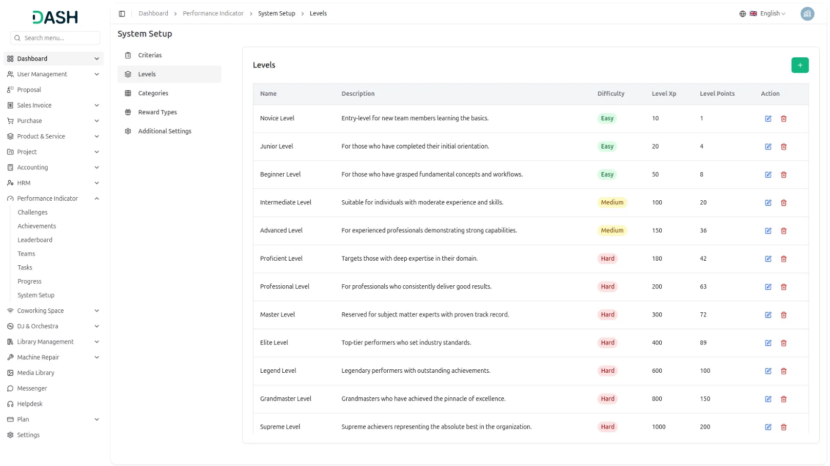
Categories
- To create a new Category, click the “Create” button, enter the Category Name, and set the Status as Active or Inactive.
- The list page shows all categories with their current status and provides Edit and Delete actions for each entry.
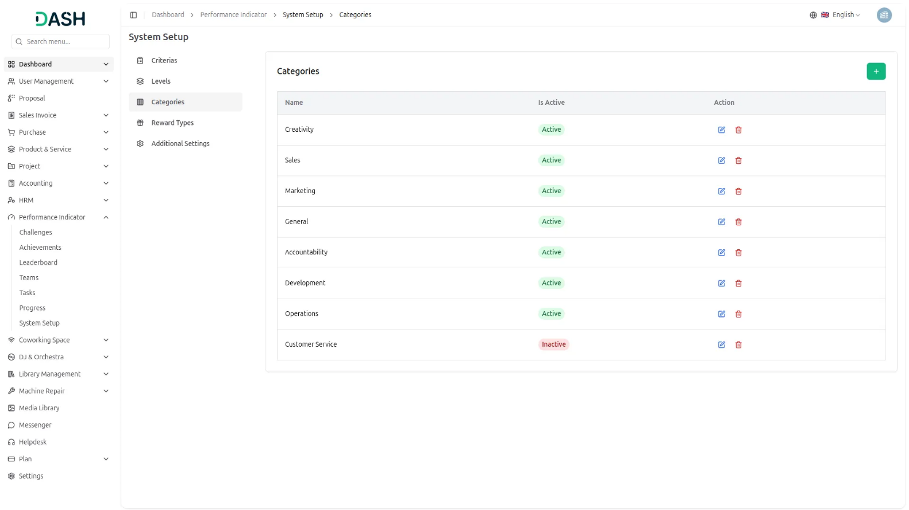
Reward Types
- To create a Reward Type, click the “Create” button, enter the Reward Type Name, select who the reward applies to, Individual, Team, or both, and set the active status.
- The list displays all reward types along with their applicability and status, with Edit and Delete options available.
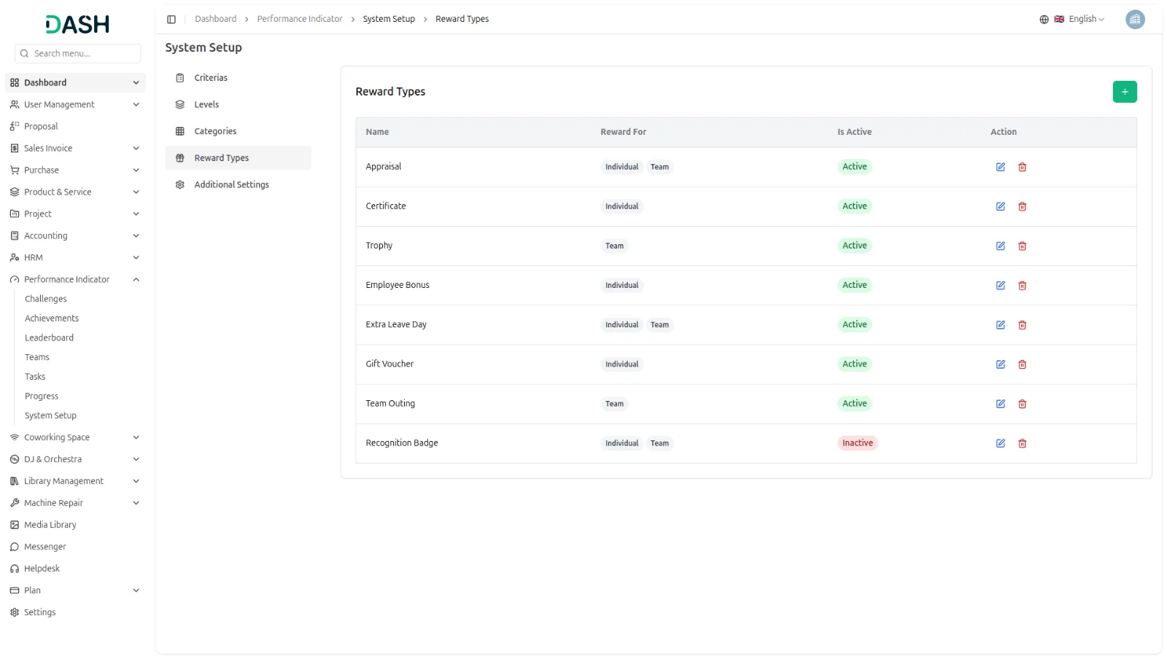
Additional Settings
- The Additional Settings page lets you control display visibility and configure the points conversion rule across the system.
- Use the toggle switches to show or hide specific fields throughout the platform, including Projects Display in Challenges, Criteria Display in Challenges, Category Display in Achievements, Reward Type Display in Achievements, Profile Image Display in Teams, and Number of Members Display in Teams.
- The Points to XP Conversion setting defines how challenge points are converted into XP for teams. For example, if 1 point equals 10 XP and a challenge awards 10 points, the team receives 100 XP. Team leaders can then distribute that converted XP to individual members based on their task contributions. Once the conversion rate is set and saved, it will apply to all new challenges going forward.
- Important Note: When changing XP conversion rates from additional settings, new challenges will use the updated score calculations, while existing challenges will retain their original score count.
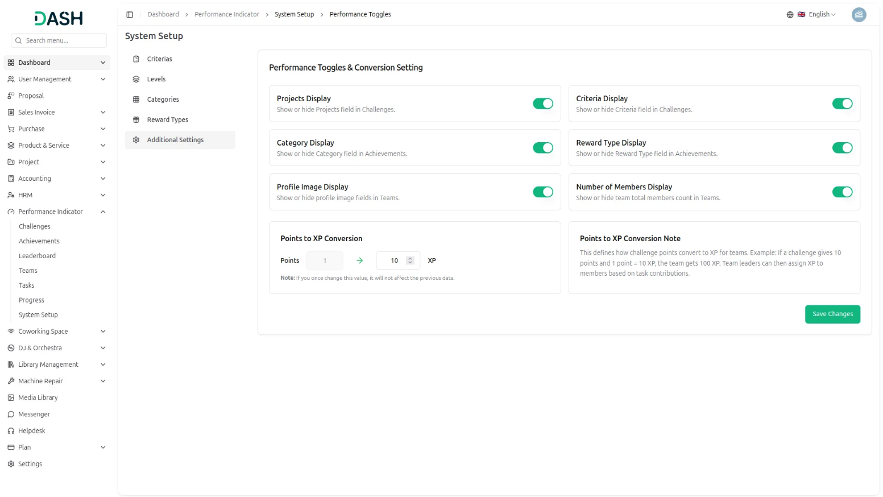
Manage Challenges
- The Manage Challenges section allows you to create, view, and manage all challenges within the system. Each challenge can be assigned to either an individual or a Team and tracked through its full lifecycle from creation to scoring.
- To create a new challenge, click the “Create” button, which is located on the challenges page. Enter Challenge Name, select the Status from the dropdown (active or inactive), set the Start Date or End Date using the date picker, choose Challenge Status from the dropdown (Upcoming, In Progress, On Hold),
- Select the Difficulty Level from the dropdown (which is configured from the System setup), choose Project from the dropdown (which comes from the project Add-On), select Criteria from the dropdown (which is configured from the System setup), and Description.
- Choose Type from the dropdown (Individual or Team). When an individual is selected, the reward type is automatically set to XP, and when a team is selected, the reward type changes to Points. It is important to choose the correct type carefully, as this field cannot be edited once the challenge is created.
- The list displays all challenges with their Name, Type, Criteria, Project, Start Date, End Date, Difficulty, and Status. The page also allows you to toggle between list view and grid view. Use the search bar to find a specific challenge by name.
- The Filters panel lets you narrow results by Challenge Type, Difficulty Status, Challenge Status, Activation Status, Criteria, Project, and Reward Type. Click Apply to run the filters or Clear to reset them. All columns support sorting in ascending or descending order.
- The Actions column displays different options based on the current status of each challenge. Here is how the actions change as a challenge moves through each status:
- When a challenge is first created, it appears in the Upcoming status. The Actions column shows four options: Score option(Clicking Score shows members/teams and max XP/Points, but scores can’t be saved until the challenge starts.) View to see the challenge details, Edit to update the challenge details, and Delete to remove permanently.
- Once the challenge becomes active, the status changes to In Progress. The Actions column shows four options: Score option (Clicking Score opens the modal with fully editable fields where you can enter the actual XP or Points earned by each member or team, and click Save Score to record the results.) View to see the challenge details, Edit to update the challenge details, and Delete to remove permanently.
- When scores are assigned to all teams or individual participants, the challenge status automatically updates to “Completed.” Once completed, only the Score and View actions remain available, while the Edit and Delete options are no longer accessible.
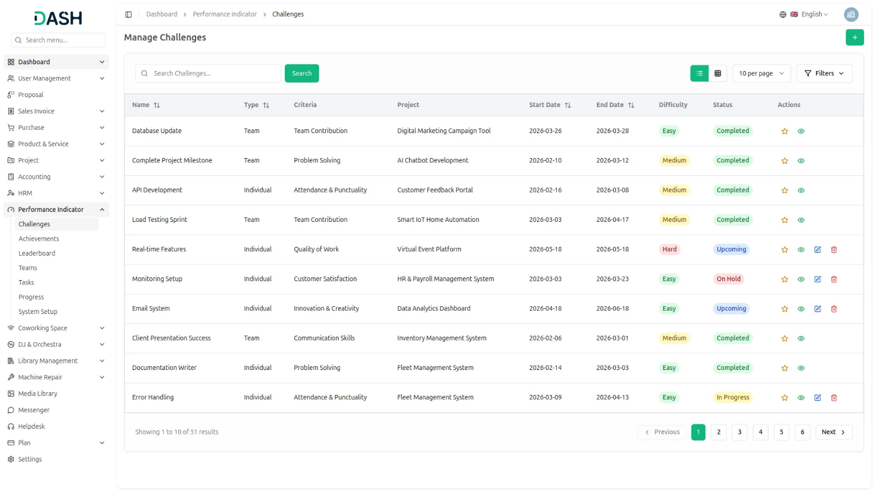
Assigning Challenge Scores
- Once a challenge is on hold and in progress, you can assign scores by clicking the Score option in the Actions column.
- For Team challenges, the score modal shows each participating team alongside their maximum points. You enter the actual points earned by each team and click Save Score.
- For Individual challenges, the score modal shows each participating member alongside their maximum XP. You enter the actual XP earned by each member and click Save Score.
- Completed challenges only show the View and Score options in the Actions column (as editing or deleting is not permitted), while In Progress, On Hold, and Upcoming challenges display the full set of actions: Score, View, Edit, and Delete.
Important Notes:
- If the challenge status is Upcoming, you cannot assign a score and will see the note: “This challenge is upcoming, so scores can’t be modified yet.”
- Once you assign a score to any team or individual member and save the score, you cannot edit the score again.
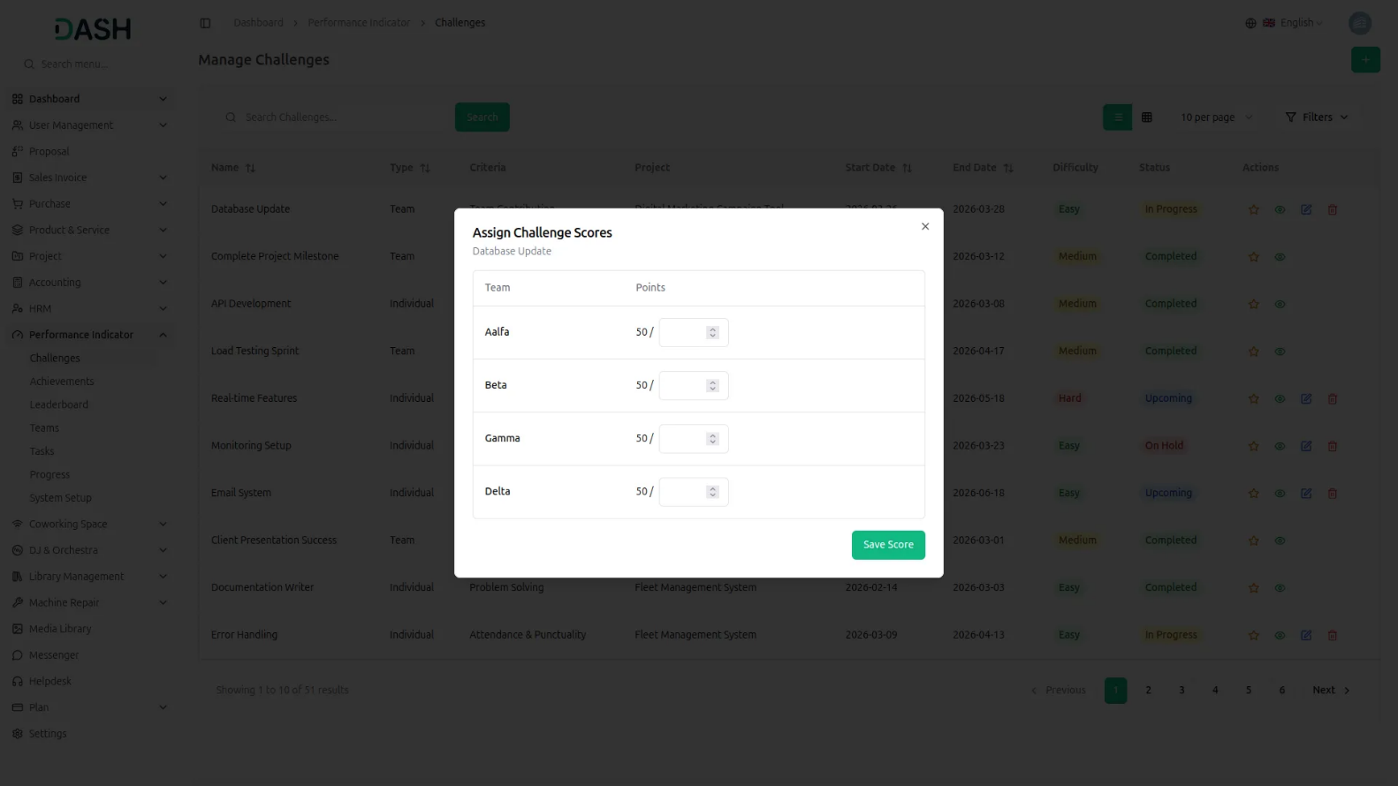
Manage Achievements
- The Manage Achievements section allows you to create, view, and manage all achievements within the system. Each achievement can be assigned to either an Individual or a Team and tracked through its full lifecycle from creation to unlocking and winner assignment.
- To create a new achievement, click the “Create” button on the Achievements page. Enter the Achievement Name, set the Activation Status as Active or Inactive, select the Reward Type from the dropdown (configured in System Setup), and select the Category from the dropdown (configured in System Setup).
- Choose type as Individual or Team. If you select Individual, you can assign fields based on XP, Level, or Both. If you select Team, you can assign fields based on Points, Level, or Both. Then enter a Description, set the Assign Mode as Auto or Manual, and choose the Award Type as Top Performer or All Performers.
- Assign Mode: There are two types of assign mode – Auto and Manual. In Auto mode, achievements are unlocked automatically by the system when conditions are met. In Manual mode, once the conditions are met, an Unlock option appears in the Action field, and the admin can click it to manually award the achievement after verification.
- Award Type: There are two types of award type – Top Performer and All Performers. In Top Performer, once the achievement is unlocked, an Assign Winner option appears in the Action field, allowing the admin to select one team or individual from the unlocked list as the winner. In All Performers, all users or teams who unlock the achievement receive it automatically.
- The list displays all achievements with their Name, Type, Category, Reward Type, Assign Mode, Award Type, Status, and Is Active columns. You can toggle between list view and grid view using the options.
- Use the search bar to find a specific achievement by name. The Filters panel lets you narrow results by Status, Is Active, Type, Assign Mode, Category, Reward Type, and Award Type. Click Apply to run the filters or Clear to reset them. All columns support sorting in ascending or descending order.
- Available Action: Unlock option is displayed when the achievement’s Assign Mode is set to Manual. Assign Winner option is displayed when the achievement’s Award Type is set to Top Performer. Additionally, you can use View to see existing data, Edit to modify it, or Delete to remove it permanently.
Important Note:
- Achievements can not be edited or deleted once the status is Unlocked.
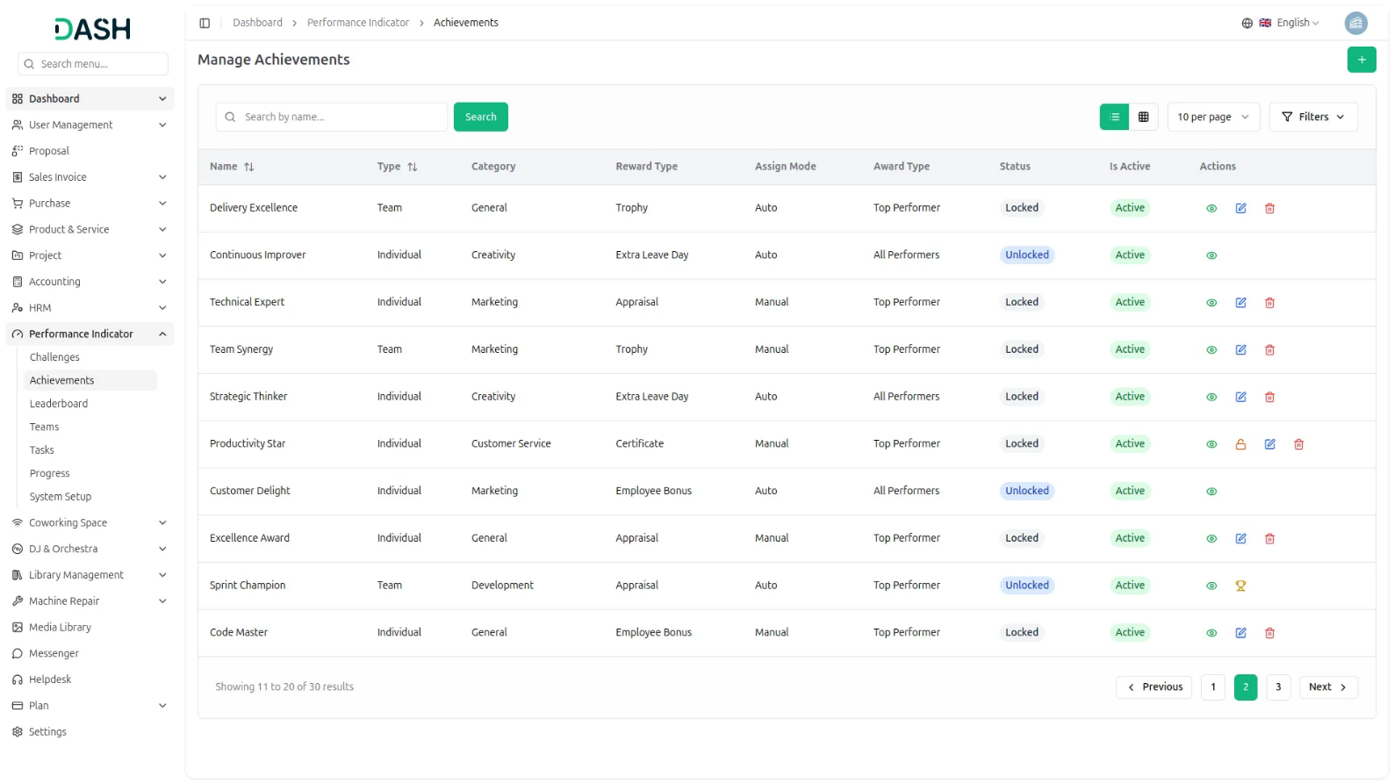
Global Leaderboard
- The Global Leaderboard provides a company-wide ranking of teams and individuals based on their performance scores. You can switch between the Team Leaderboard and Individual Leaderboard using the toggle tabs at the top right of the page. Use the search bar to quickly find a specific team or individual by name.
- The Team Leaderboard displays all teams ranked by their Total Points. Each row shows the team’s Rank, Team Image, Team Name, Team Leader name and email, Team Members avatars, Top Contributor with their XP, current Level, and Total Points. All columns support sorting in ascending or descending order.
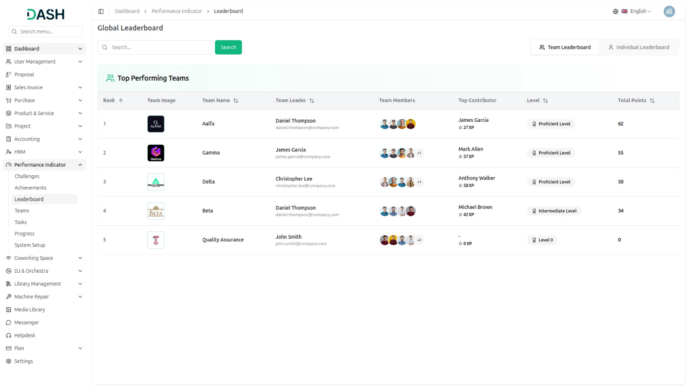
- The Individual Leaderboard displays all members ranked by their Total XP. Each row shows the member’s Rank, Avatar, Name, Email, current Level, and Total XP. All columns support sorting in ascending or descending order.
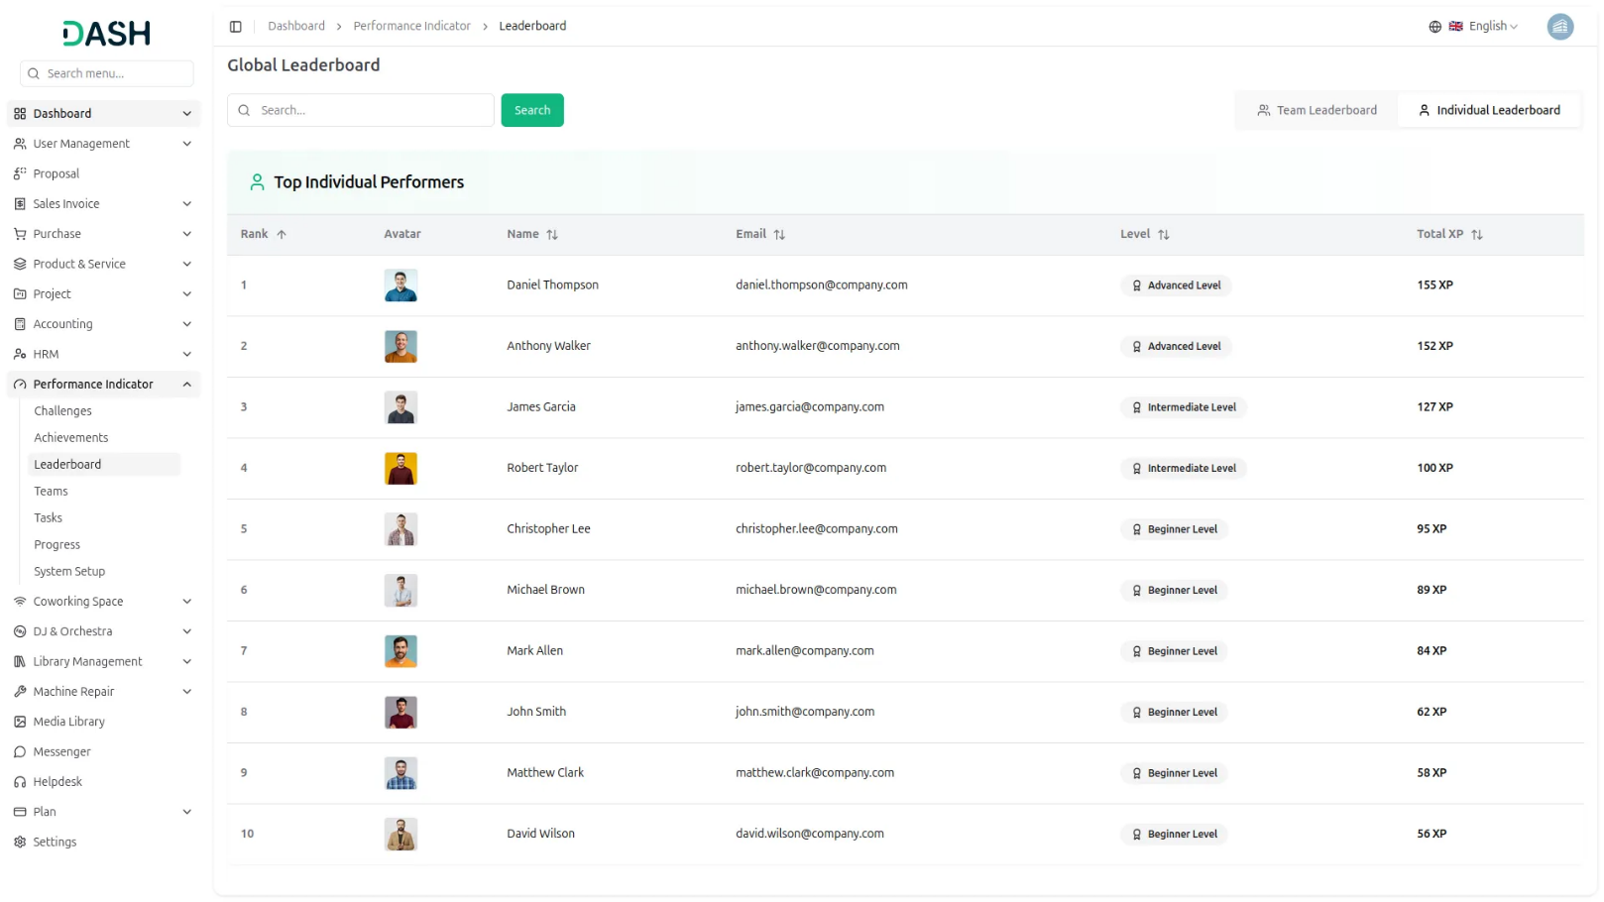
Manage Teams
- The Manage Teams section allows you to create, view, and manage all teams within the system. Each team is assigned a leader and members, and its performance is tracked through points and levels earned from challenges.
- To create a new team, click the “Create” button on the Teams page. Enter the Team Name, select the Team Leader from the dropdown, select the Team Members using the multi-select dropdown, enter a Badge, set the Is Active status as Active or Inactive, upload a Profile Image, and enter a Description. Click Create to save the team.
- The list displays all teams with their Profile Image, Rank, Team Name, Team Leader, Team Members’ avatars, Total Members count, Level, Total Points, and Is Active status.
- You can toggle between list view and grid view using the button. Use the search bar to find a specific team by name. The Filters panel lets you narrow results by Level and Is Active status. Click Apply to run the filters or Clear to reset them. The Rank and Team Name, Team Leader, and Total Points columns support sorting in ascending or descending order.
- Available actions: the View option to see the full team details, the Edit option to modify team information, and the Delete option to permanently remove the team from the system.
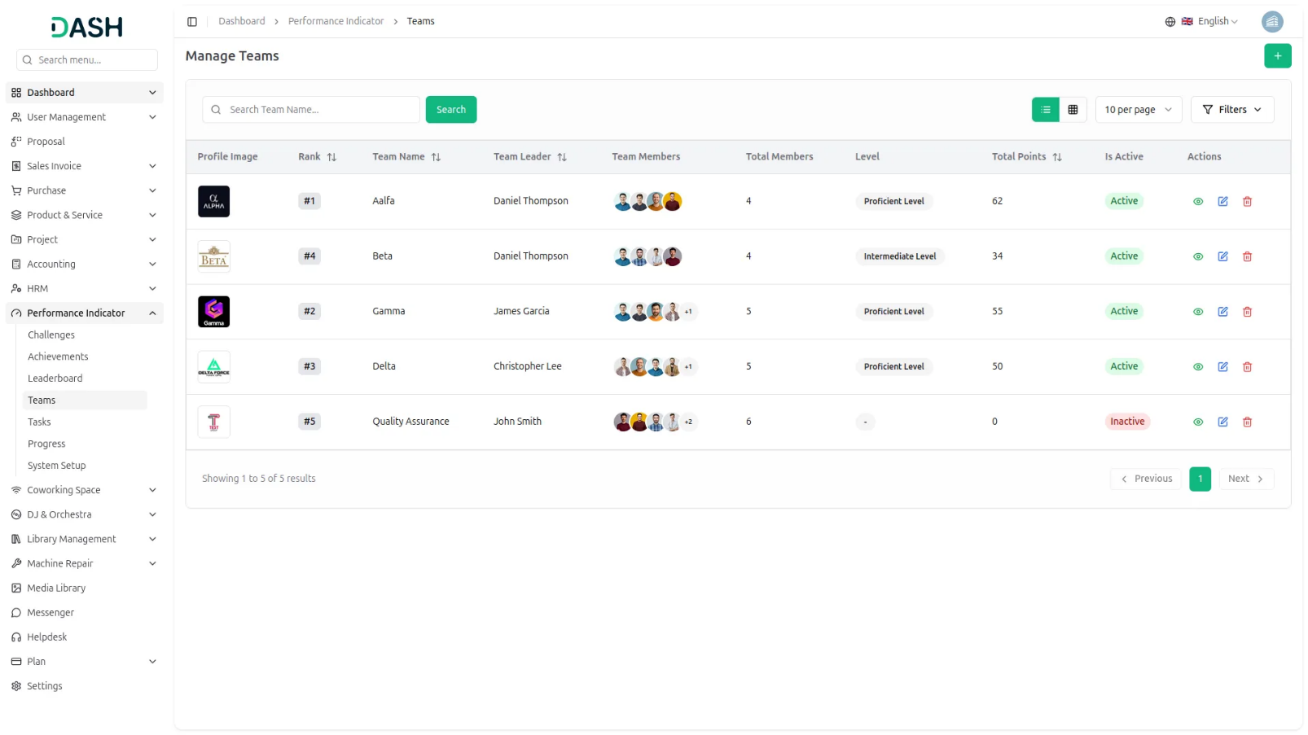
Team Details
- Clicking the View option on any team opens the Team Details page, which provides a complete overview of that team’s profile, members, challenges, and tasks.
- The top left panel displays the team’s profile image, name, active status, Current Level, Leader Name and email, Team Rank, Total Points, and Team Description.
- The Team Members panel on the right lists all members currently assigned to the team, showing each member’s Avatar, Name, Email, and Total XP. A delete option is available next to each member, allowing the admin to remove a member from the team directly from this panel. The total member count is displayed at the top right of the panel.
- The Team’s Challenges section lists all challenges assigned to the team, showing the Title, Points, Start Date, End Date, Difficulty, Status, and a View Description action for each challenge. A note at the top of this section displays the current Points to XP conversion rate for reference. The total number of challenges is shown at the top right of the section.
- The Team’s Tasks section lists all tasks assigned to team members across active challenges, displaying the Task Name, Challenge Name, Team Member, Estimation Time, XP, Start Date, End Date, Status, and a View Description action for each task. The total number of tasks is shown at the top right of the section.
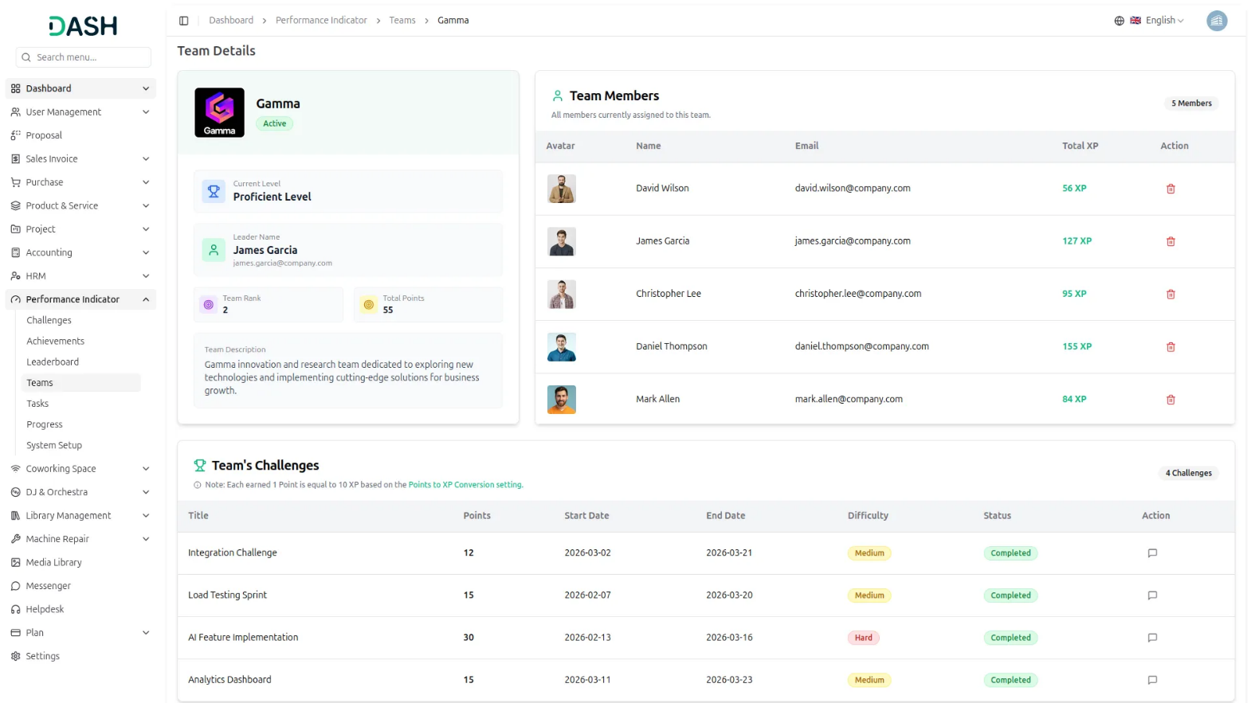
Team Tasks
- The Manage Team Tasks section allows you to create, view, and manage all tasks assigned to teams within the system. Each task is linked to a specific team, challenge, and member, and is tracked through its lifecycle from creation to scoring.
- To create a new task, click the “Create” button on the Team Tasks page. Enter the Task Name, select the Task Status from the dropdown as Upcoming, In Progress, or On Hold. Based on the selected team, you need to choose the corresponding team challenge and team member. the task is assigned to, enter the Earned XP, set the Start Date and End Date using the date picker, enter the Estimation Time in minutes, enter a Badge, and add a Description.
- The XP Information section at the bottom of the form displays the Total XP, Used XP, and Available XP for the selected team and challenge, helping you stay within the allowed budget before saving the task.
- The list displays all tasks with their Task Name, Team Name, Challenge Name, Assigned To, Start Date, End Date, Earned XP, and Status columns. You can toggle between list view and grid view using the option.
- Use the search bar to find a specific task by name. The Filters panel lets you narrow results by Team Name, Challenge Name, and Status. Click Apply to run the filters or Clear to reset them. The Task Name, Team Name, Start Date, End Date, and Status columns support sorting in ascending or descending order.
- The Actions column displays different options based on the current status of each task. Here is how the actions change as a task moves through each status:
- When a task is first created, it appears in Upcoming status. The Actions column shows three options: Give Score option (Clicking Give Score opens the Task Scoring modal, showing the full task details, but displays a message indicating that this task is upcoming and scores cannot be modified yet.) Edit to update the task details, and Delete to remove permanently.
- Once the task becomes active, the status changes to In Progress. The Actions column shows three options: Give Score option (Clicking Give Score opens the Task Scoring modal showing the full task details, but if the parent challenge is not yet completed, a message appears indicating that score assignment is locked because the challenge is not yet completed.) Edit to update the task details, and Delete to remove permanently.
- Once a challenge is marked as complete, you can click the “Give Score” option to assign scores to the individual tasks within that challenge. Upon assigning the score, the status of the task will automatically update to “Completed.”
- Clicking on the “Give Score” option opens a Task Scoring modal where you can enter the XP score for the team member. The modal will display the full task details, the XP entered, the maximum XP allowed, a budget progress bar, the total used XP, and the team limit for the challenge. Once the score is assigned and the task is marked as completed, the “Edit” and “Delete” options will no longer be available for that task.
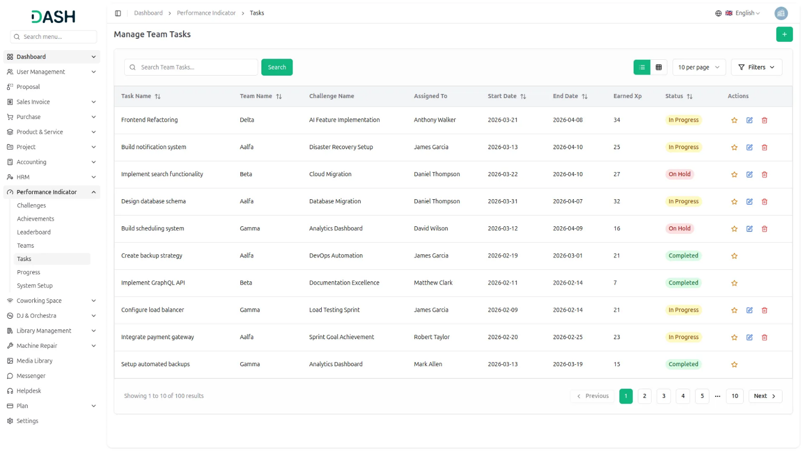
Progress Management
- When a company admin logs in, they can access the Manage Members page and view the progress of all employees registered within the system. When Team Leder and employees log in, they are able to view only their individual progress. This ensures that each user sees information relevant to their role while maintaining proper access control.
- The list displays each member’s Avatar, Member Name, Member Email, and Level. The Member Name, Member Email, and Level columns support sorting in ascending or descending order. Each member has a single View action available, which opens the full profile details of that member.
- Clicking the View action opens the Progress Overview page, which provides a complete summary of an individual member’s performance. This page can be accessed from the Manage Members list by selecting View for any member.
- At the top of the page, you’ll see the member’s avatar, name, email, and current level badge. It also includes a summary of their earned Tasks XP compared to the total available, as well as Challenges XP earned versus the total.
- Alongside this, the Progress panel displays the member’s overall progress as a percentage with a visual progress bar and lists all badges the member has earned.
- The Level Details panel shows the member’s current standing level, the next level they are working toward, how much XP remains to reach that next level, their Current XP, and their Goal XP.
- The Unlocked Achievements section lists all achievements the member has earned, showing the achievement number, Achievement Name, Category, Reward Type, and a View Description action that opens the description of that achievement.
- The My Team Contribution section shows all teams the member belongs to, displaying the team Logo, Team Name, Tasks Completed count, Progress percentage with a progress bar, XP earned versus the total available, and Team Status.
- The My Tasks section lists all active tasks assigned to the member, showing the task number, Task Name, Team Name, Challenge Name, XP earned versus total, Start Date, End Date, Status, and a View Description action.
- The My Challenges section lists all challenges the member is participating in, displaying the challenge number, Challenge Name, Criteria, XP earned versus total, Start Date, End Date, Difficulty, Status, and a View Description action.
- The Upcoming Tasks section shows tasks that are scheduled but not yet started, displaying the Task Name, XP, Team Name, Start Date, and a View Description action.
- The Upcoming Challenges section shows challenges that are scheduled but not yet started, displaying the Challenge Name, XP, Difficulty, Start Date, and a View Description action.
- The Overdue Tasks section highlights tasks that have passed their end date without being completed, showing the Task Name, XP, Team Name, and End Date displayed in red to signal the overdue status, and a View Description action.
- The Overdue Challenges section highlights challenges that have passed their end date without being completed, displaying the Challenge Name, XP, Difficulty, End Date in red, and a View Description action.
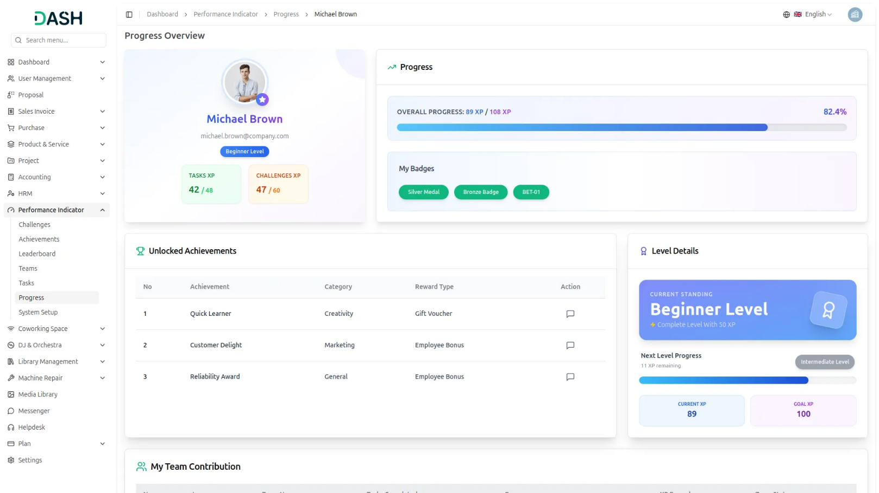

Understanding Points & XP
- The system uses two separate performance currencies, Points and XP, that work together to measure and reward both team and individual performance.
- Points are earned by Teams when an admin scores a completed Team challenge. Each participating team receives Points out of a maximum allowed score based on their performance.
- XP (Experience Points) is the individual currency each member earns. XP comes from two sources: directly from Individual challenges and from Tasks assigned by their Team Leader.
How Points Convert to XP
- The Points to XP Conversion rate, configured in Additional Settings, determines how team Points translate into an XP budget for task distribution.
- For example, if 1 Point = 10 XP and a team earns 40 Points, the team receives 400 XP to distribute among members through tasks. The Task Scoring modal displays the Total XP budget, Used XP, and Remaining XP so the Team Leader always knows how much is left to assign.
How XP Appears on Member Profiles
- On the Progress Overview page, XP is split into two totals: Tasks XP earned through tasks distributed by the Team Leader, and Challenges XP earned directly from Individual challenges. Both are combined to calculate the member’s Overall Progress and determine their current Level.
Important Note: Changing the Points to XP conversion rate will only affect new challenges created after the update. Existing challenges retain their original XP calculations.
System Workflow
Summary
The Performance Indicator system operates through a structured workflow where companies manage teams and individual members through challenges and achievements:
- Teams and Individual Members: Companies create teams with designated leaders and assign both team-based and individual challenges
- Challenge Assignment: Challenges are assigned to teams (earning points) and individuals (earning XP directly)
- Points to XP Conversion: When teams complete challenges and earn points, these are converted to XP using system settings (e.g., 1 point = 10 XP)
- Task Distribution: Team Leaders receive converted XP and create tasks for team members, distributing XP as rewards upon task completion
- Achievement System: Achievements are unlocked when teams or individuals reach specific XP, Points, or Level thresholds
- Personal Progress: Individual XP from both tasks and individual challenges contributes to personal achievements and level progression
Example Workflow
Step 1: Challenge Assignment:
- The company assigns a “Marketing Campaign” challenge to Team Alpha.
- If Team Alpha completes this task on time, the company gives 10 points as a reward.
Step 2: Points-to-XP Conversion
The company gives Team Alpha 10 points upon completing the challenge. As per the Points-to-XP Conversion setting:
- Reward Score: 10 Points
- System Conversion Rate: 1 Point = 10 XP
- Total XP Generated: 10 Points × 10 = 100 XP
- Note: This XP is handed over to the Team Leader for distribution.
Step 3: XP Distribution Setup by Team Leader
- Team Leader Alex decides in advance how the 100 XP (which the team will get after completing the challenge) will be shared among team members, based on how difficult each task is or how much each member is contributing.
- Task 1 (Content Writing) → Riya: 40 XP
- Task 2 (Design Work) → Raj: 60 XP
- The team leader creates tasks, assigns members, and plans the XP distribution in advance for the team challenge.
Step 4: Overdue Challenge Scenario (Optional Variation)
- If the team completes the challenge after the deadline, the company can reduce the reward points as a penalty.
- In this case, Team Alpha finished the challenge 2 days late, so instead of giving 10 Points, the company awarded only 8 Points.
- XP Becomes: 8 Points × 10 = 80 XP
- Team Leader Alex then distributed the reduced XP as follows:
- Riya: 30 XP
- Raj: 50 XP
- This kind of penalty system encourages team members to complete tasks on time by linking performance with rewards.
Step 5: Task Completion by Members
- Once team members complete their assigned tasks:
- They instantly receive the corresponding XP.
- Riya completes her task → gains 30 of 40 XP
- Raj completes his task → gains 50 of 60 XP
- These XP values are added to their personal profile.
Step 6: Individual Challenge Participation
- Apart from team-based challenges, individuals may also take on Personal Challenges.
- Raj completes an individual challenge and earns 50 XP.
- This is awarded directly by the company, separate from the team’s XP flow.
Step 7: XP Calculation Final XP totals:
- Raj’s Total XP = XP from Team Task (50 XP) + Individual Challenge (50 XP) = 100XP
- Riya’s Total XP = XP from Team Task (30 XP) = 30XP
Step 8: Achievement Unlocking & Level-Up
- Achievements are tied to reaching certain XP milestones Suppose “Creative Achiever” requires 100 XP.
- Raj unlocks this achievement and levels up, while Riya continues working toward the threshold.
- This workflow demonstrates how the Performance Indicator system creates a comprehensive gamification experience that motivates both team collaboration and individual excellence through structured challenges, task management, and achievement recognition.

